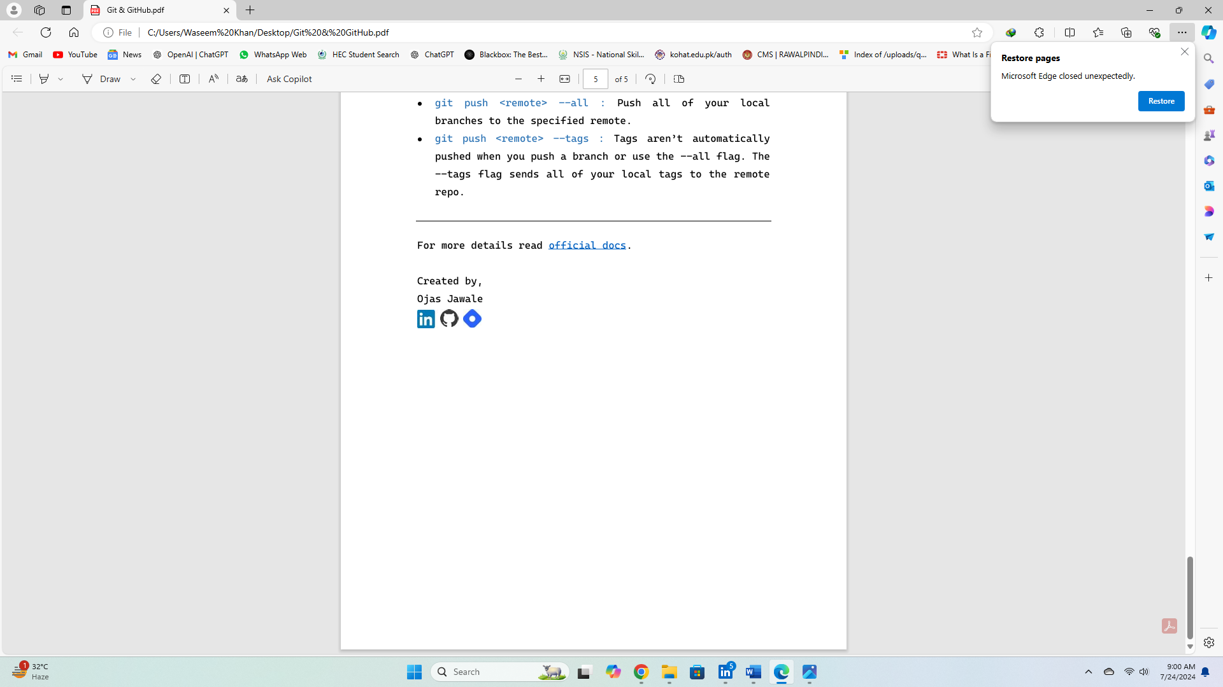

**Waseem Khan**

How to create EC2 (Elastic Cloud) Instance

(Free Tier)

1)Login or sing up in AWS Website

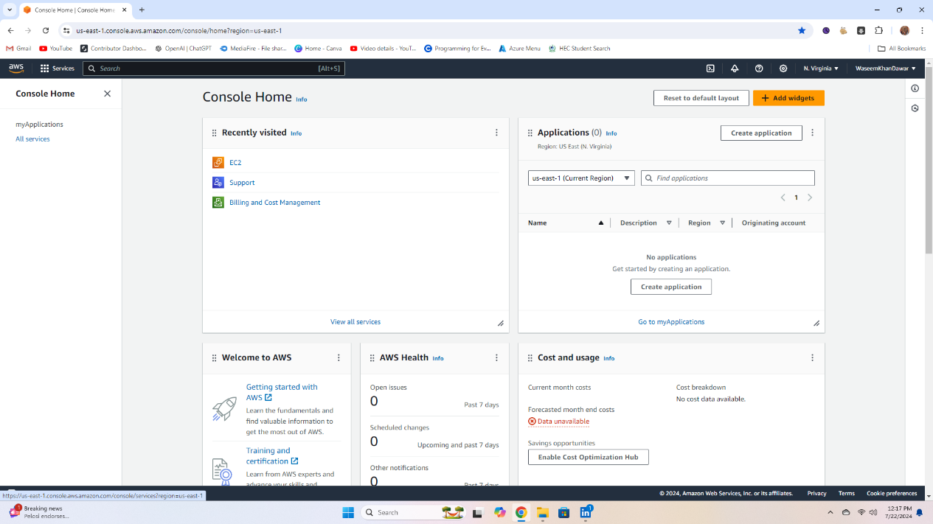2)You will see a page like the Below Image



3) Click the icon to the left of 'Services’.

The following services will be shown after a click.

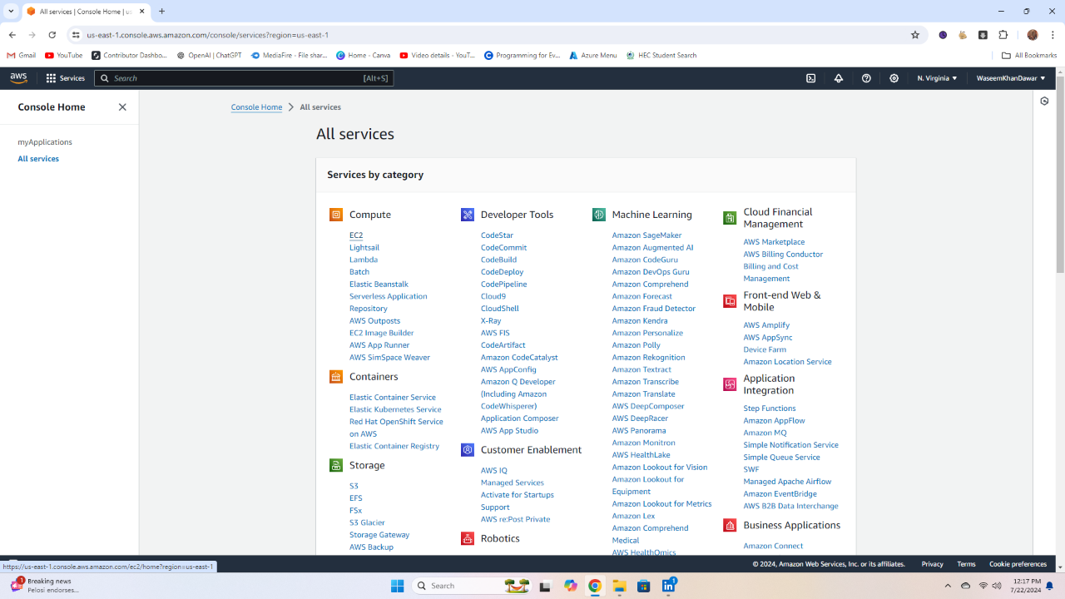

4) Then, click on EC2 under Compute.

Then, you will see a page like this.

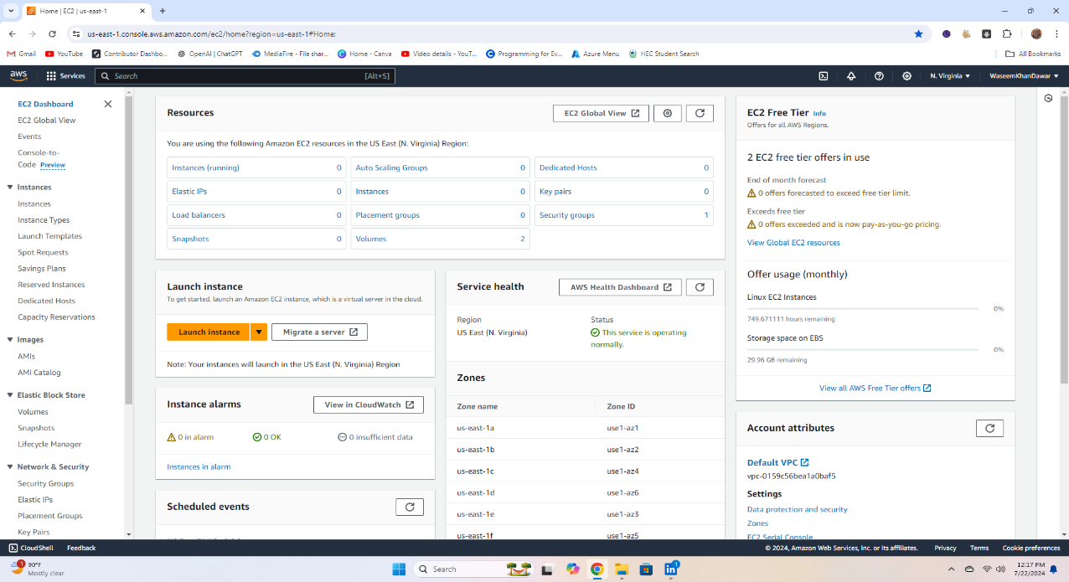



5) Click on Launch Instance (highlighted text).

then it will show the page below.

NAMES AND TAGS

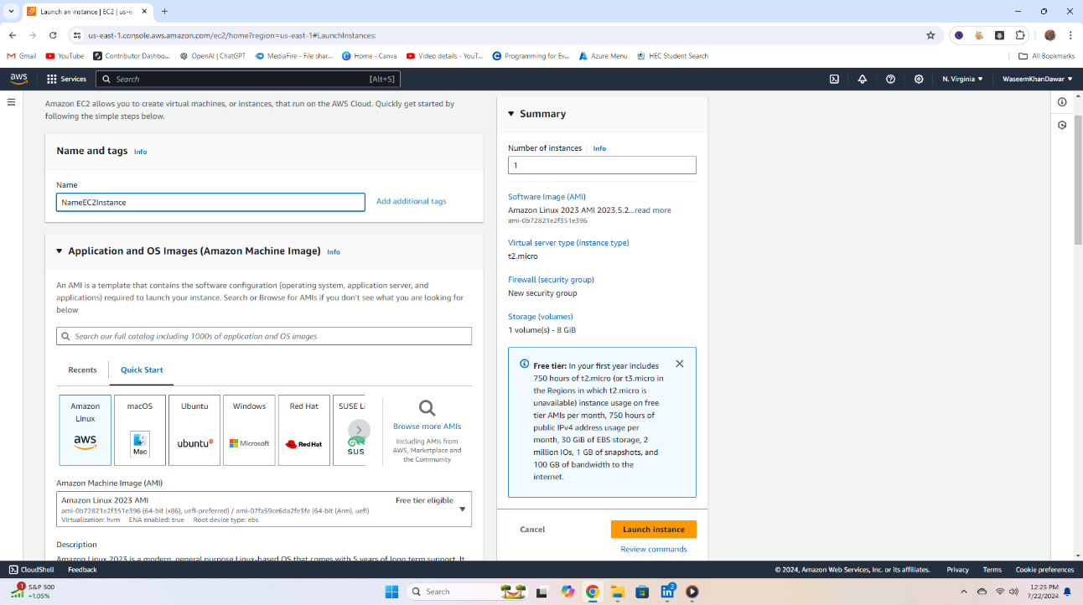



6) Enter any name you want for the instance in the 'Name' field.

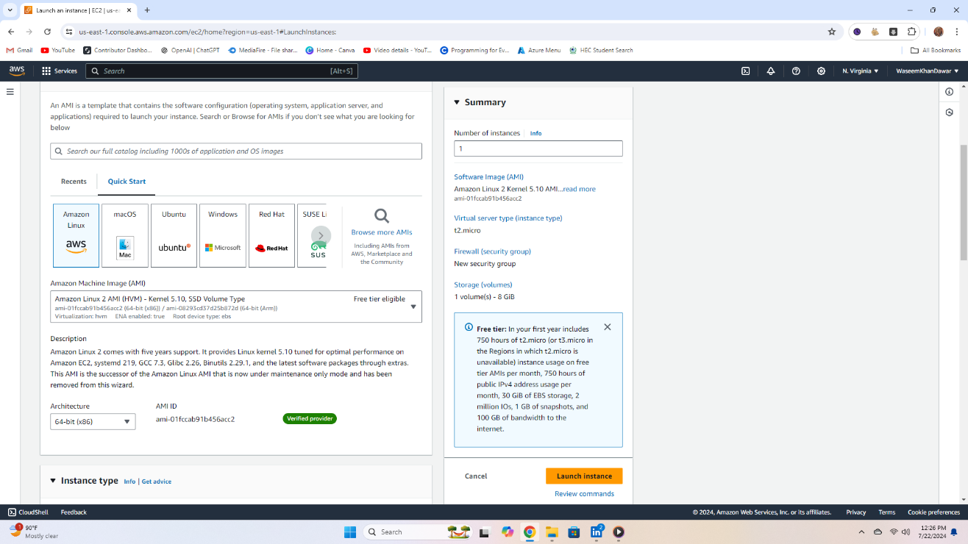



7) Choose an AMI (OS) image in 'Application and OS Images (Amazon Machine Image)'. Click the Amazon Linux logo.

APPLICATION AND OS IMAGE (AMAZON MACHINE IMAGE



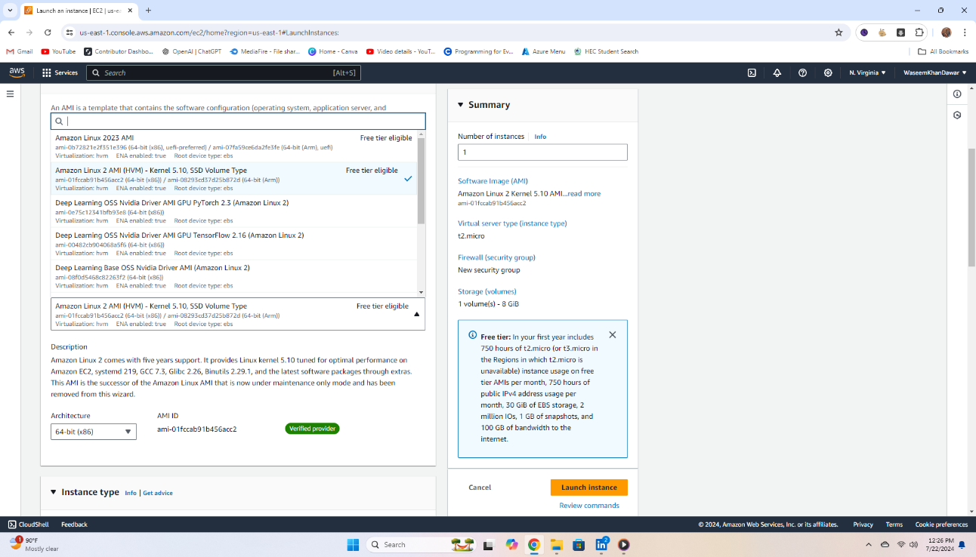



8) When you click 'Amazon Machine Image (AMI)', different images will be available. We will choose the version before the latest Linux version because the latest version might have bugs.



KEY PAIR

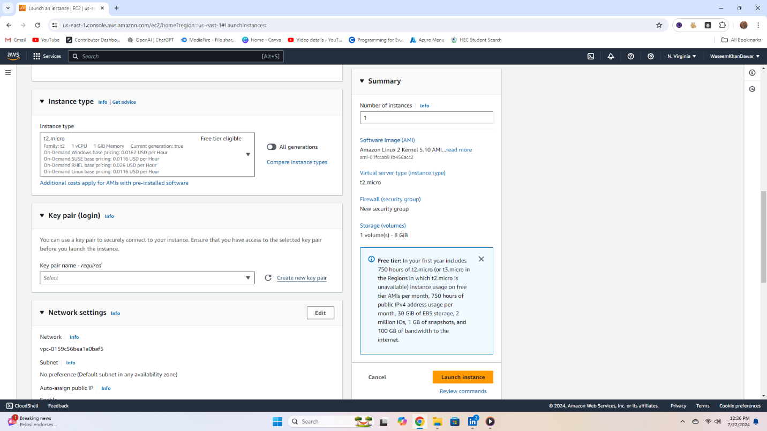



9) Now go to the next step, 'Key Pair (login)'. Click 'Create new key pair'. It will look like the image below.



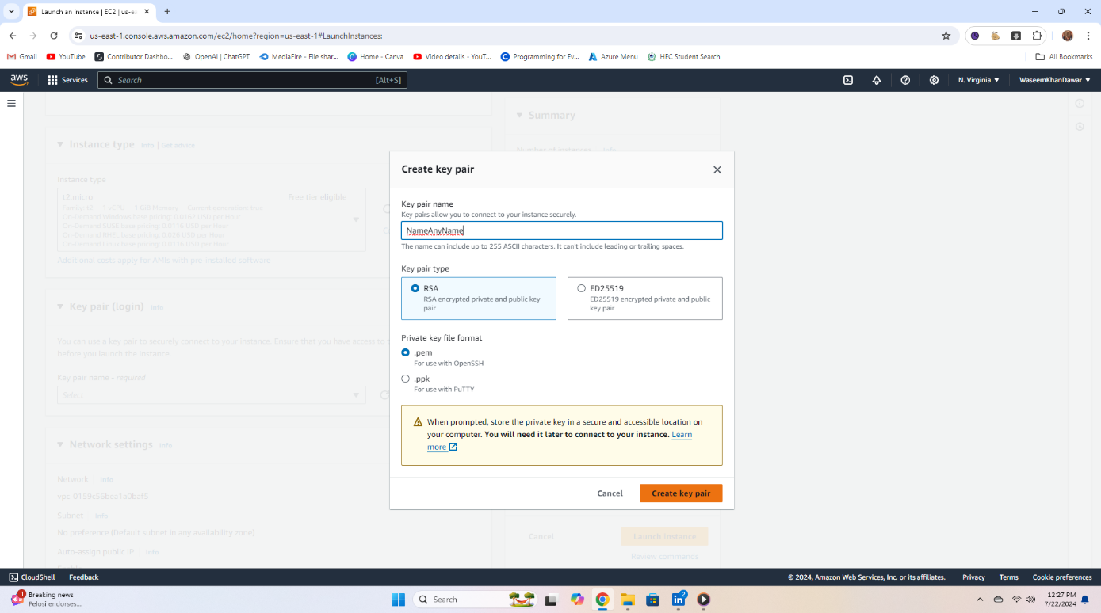



10) Now, write the name of the key pair in the field labeled 'Key pair name'. You can rename it to any name you choose. Then, leave the 'Key pair type' as the default and also leave the key format as '.pem'. When you click 'Create key pair', a file named 'name_given_by_you.pem' with the format '.pem' will be downloaded. This file contains your private key, which you must store securely and not delete.



NETWORK SETTING

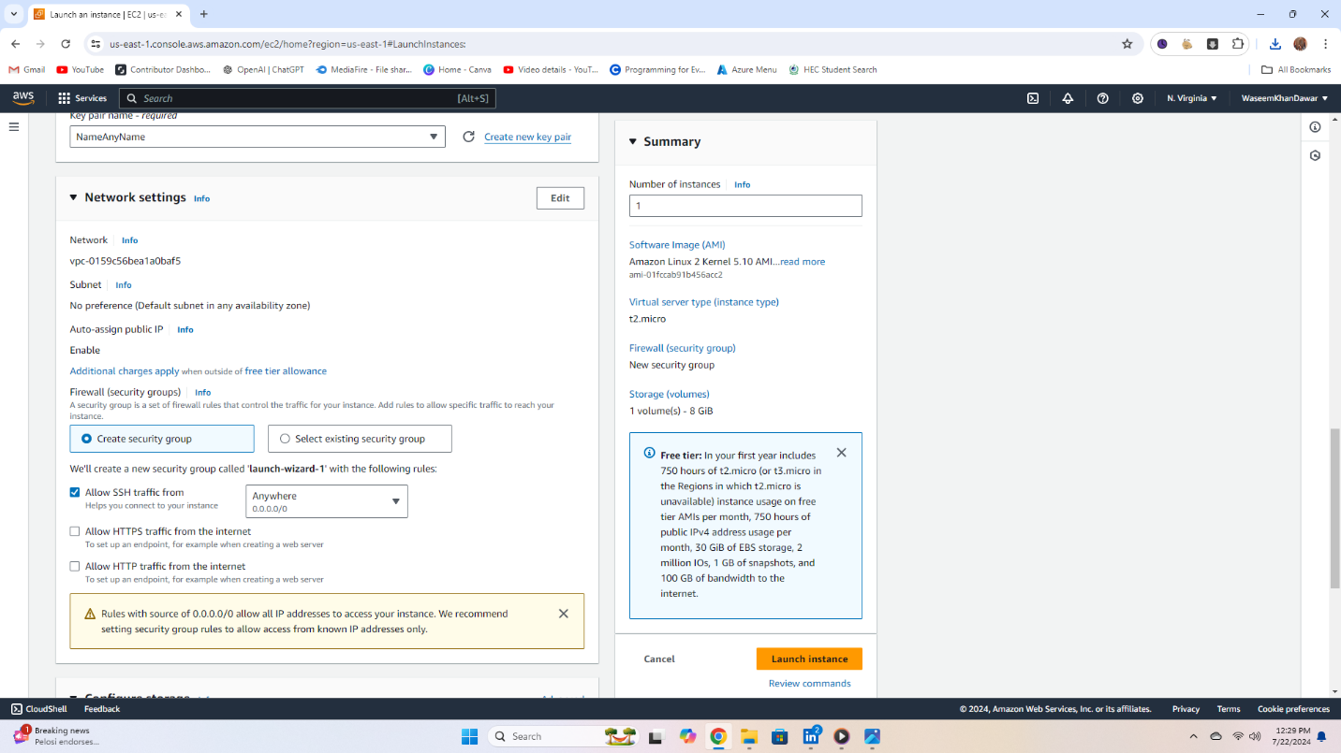



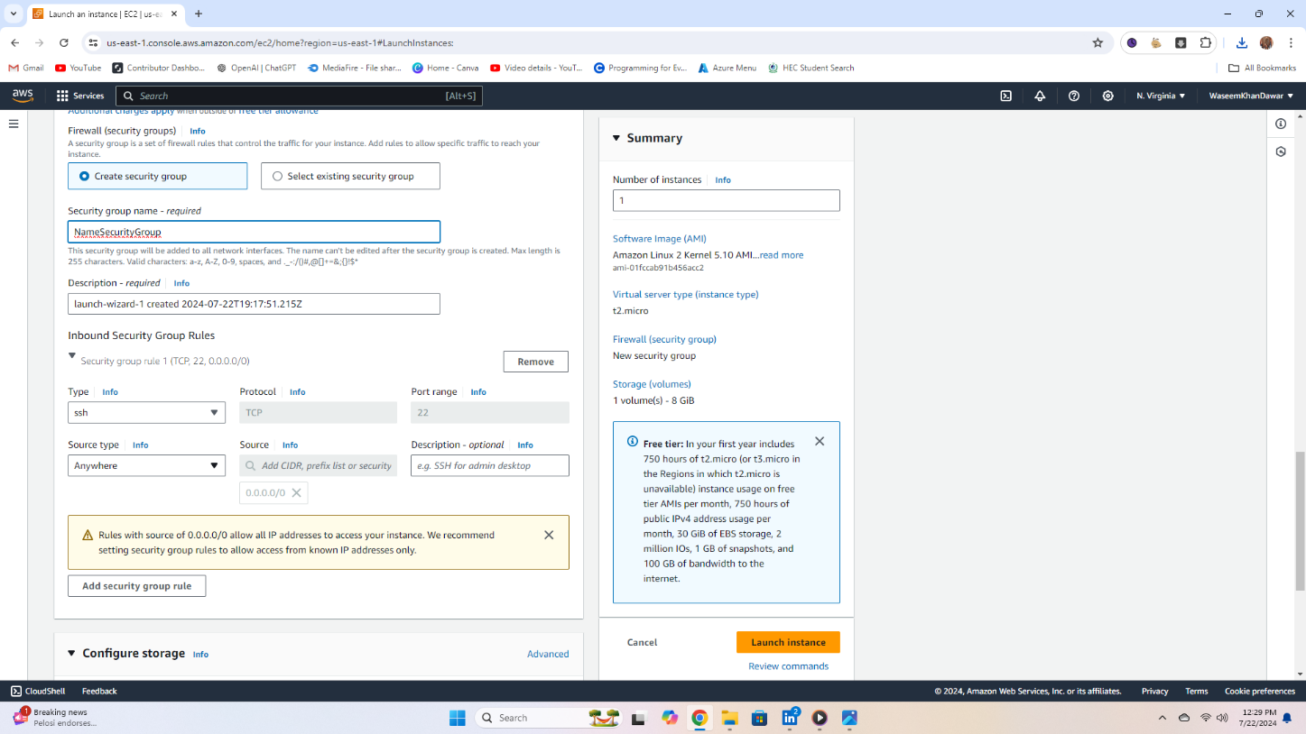11) Click the 'Edit' button to the right of 'Network Setting'. when click edit It will then look like the image below.



12) Name the security group in the 'Security group name' field. You can write any name you want. Then, leave the rest as default and click the button (Add Security group role) in the bottom left corner. then it will show like the below image.

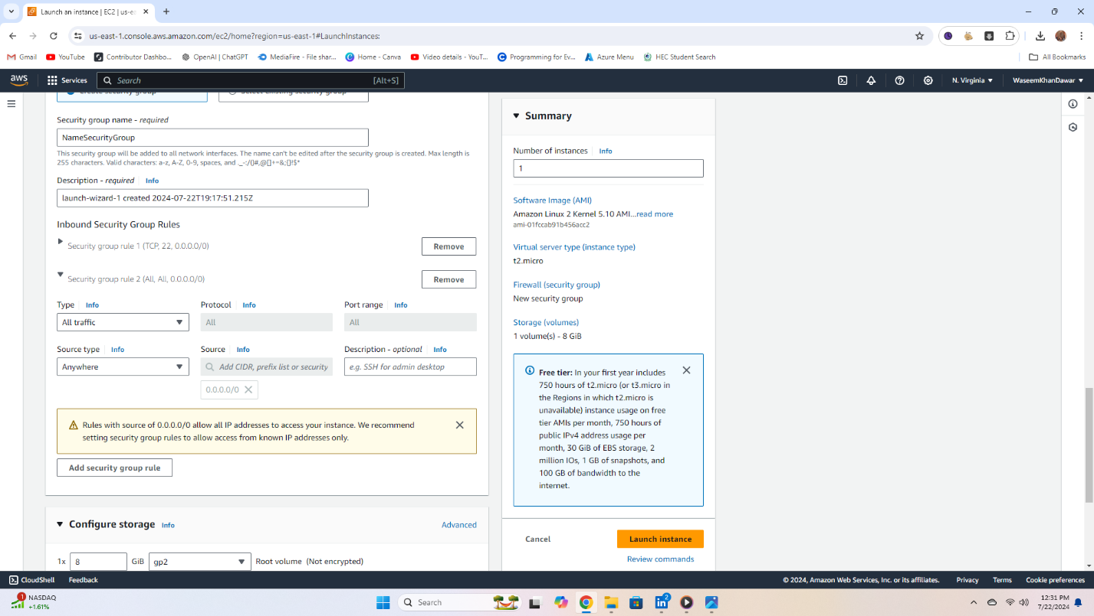

13) In the 'Type' dropdown, choose the option 'All traffic'. In the 'Source type' dropdown, choose the option 'Anywhere'.

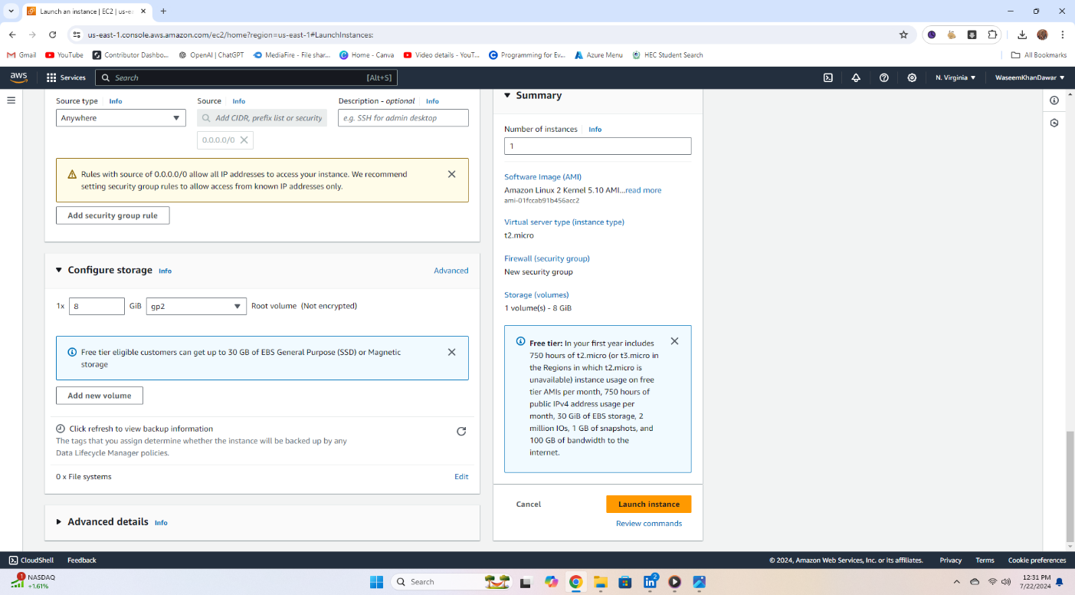CONFIGURE STORAGE

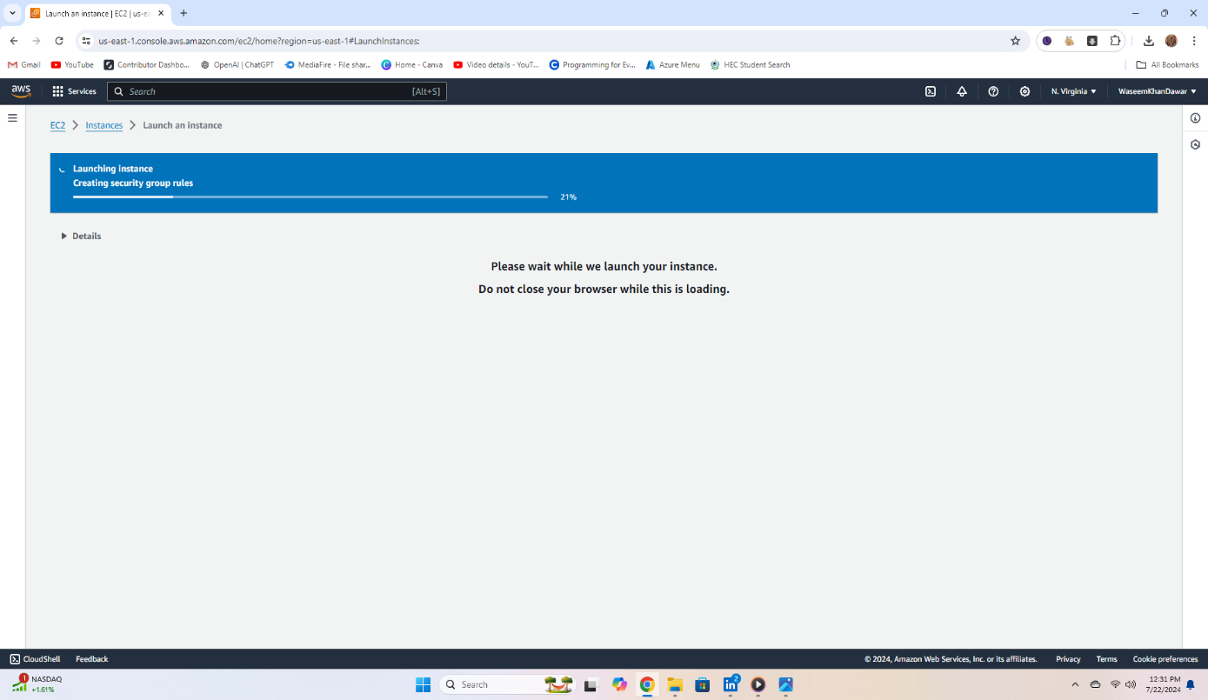14) Leave all the storage settings as they are since we will use the free tier. Then click the 'Launch instance' button, which is highlighted on the right-side bar. When you click the button, it will look like the image below.

15) After waiting for the instance lunching. you will see like the below image.

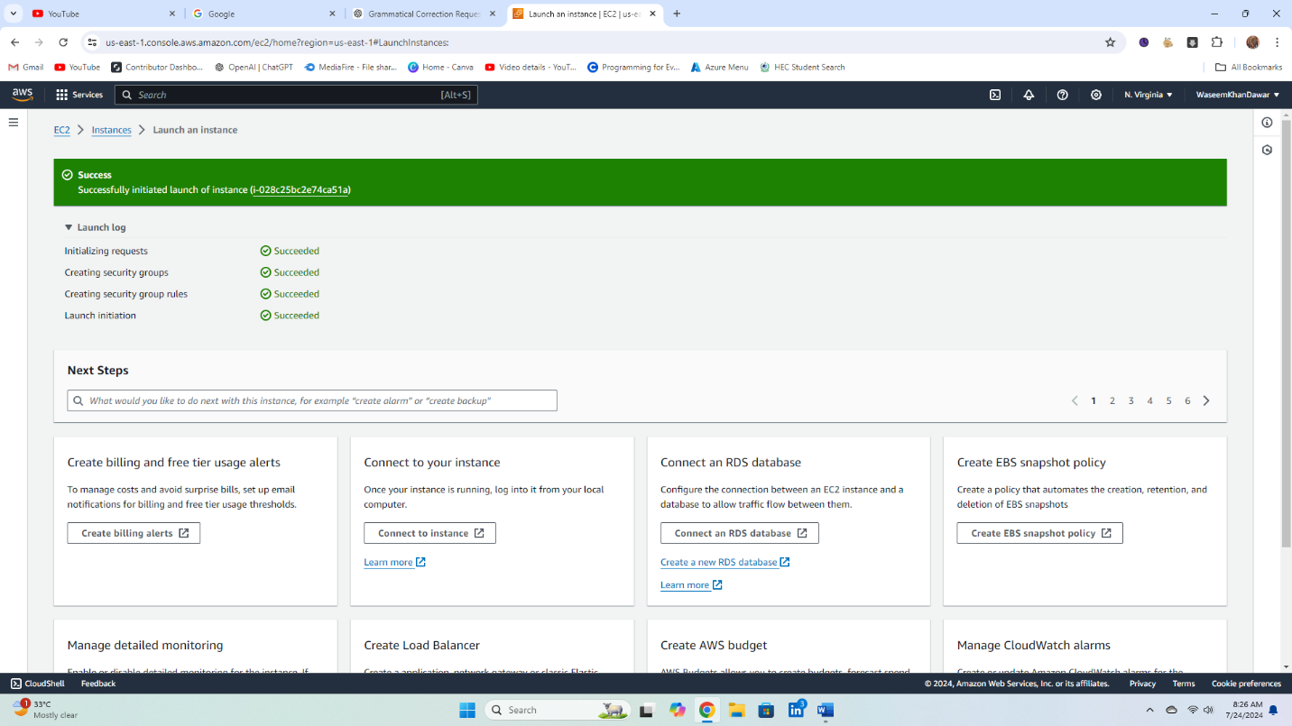



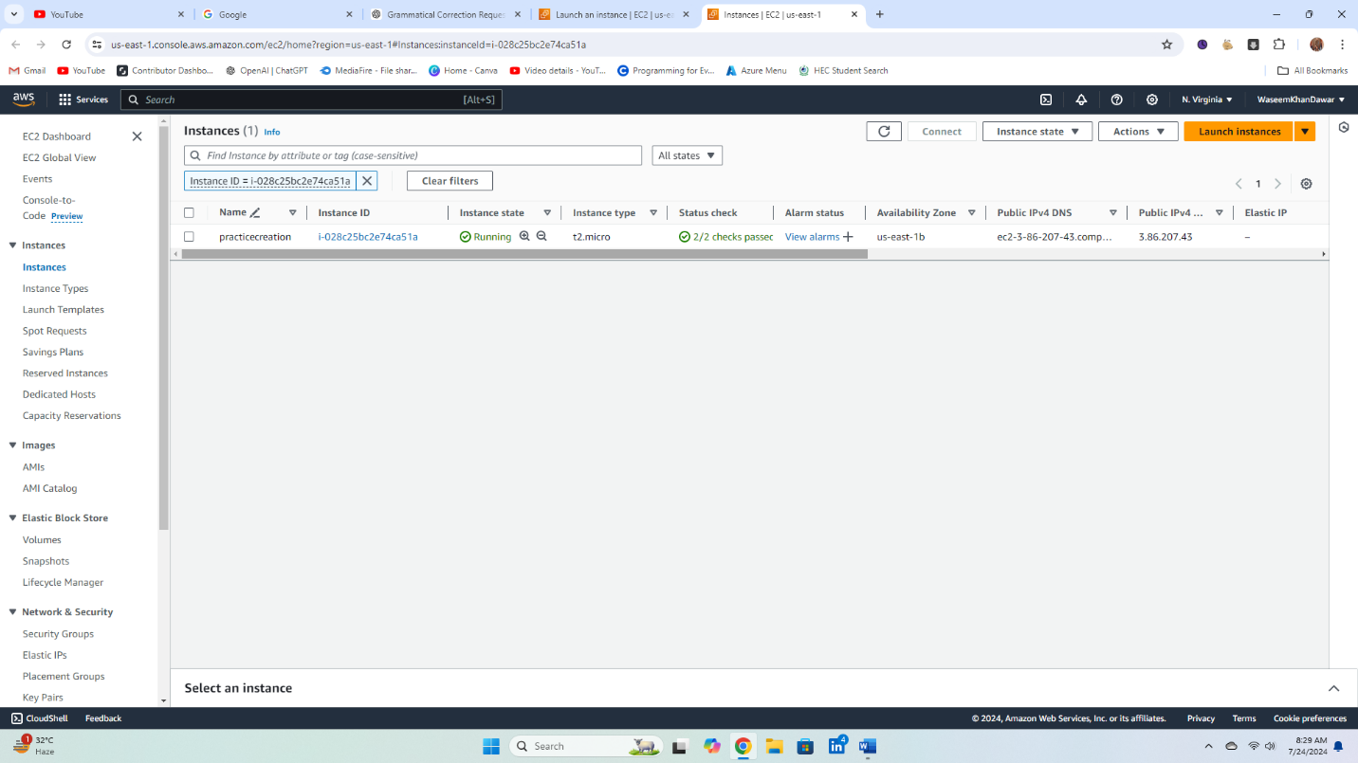16)Now when you click the underlined string. it will take you to instance



17) Now, tick the checkbox to the left of the instance name and click the 'Connect' button. Alternatively, you can click the 'Actions' button and then select 'Connect' to connect your instance. And when it connects it will show like the below image. and you can use your AMI(OS).

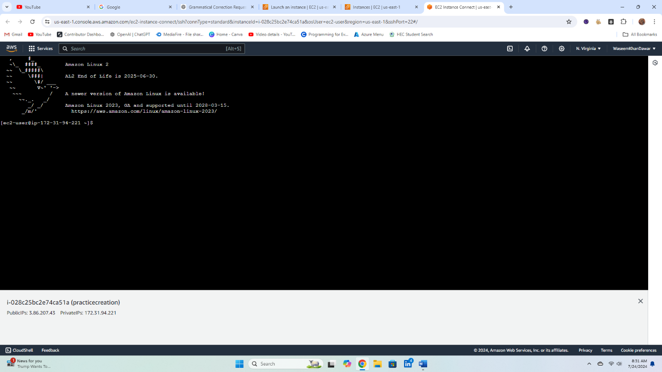

Created By,

Waseem Khan

